**Response to Reviewer’s Comments – ICOEI 2023**

**Title: Hyperspectral Image clustering and local feature selection using Gini Impurity**

We sincerely thank the two anonymous reviewers for their valuable time and efforts. Their comments and suggestions have improved the quality of this manuscript. The major improvements/changes we have made are as follows:

* Diagrams of good quality and with high resolution have been added to the revised manuscript.
* Few more references have been added to the revised manuscript.
* Introduction part is revised for perfect representation of the scope of the paper and added to the revised manuscript.

In addition, we made a few minor corrections to improve the overall readability of the manuscript. Please find below the responses to the comments.

**Reviewer(s) Comments:**

**Reviewer – 1**

“Hyperspectral image clustering and local feature selection using gini impurity” is the proposed title of this paper.

Yes, title of research paper is “Hyperspectral Image clustering and local feature selection using Gini Impurity”

Keyword should be start with capital letter.

In response to suggestion, the revised manuscript now includes updated keywords.

In what way Gini Impurity used to recognize the significant segments?

As mentioned in the Abstract, Gini Impurity measures the probability for a random instance being misclassified when chosen randomly. The lower the Gini Impurity, the lower the likelihood of misclassification.

As per the definition of Gini Impurity, lower Gini Impurity implies that for a segment most of the pixel values are similar. Gini Impurity for each segment is calculated and these segments are arranged in ascending order to recognize the significant segment.

How to perform the image segmentation process?

There are various methods for performing image segmentation. Here in the paper, *k*-means clustering is utilized for performing image segmentation. As a result of *k*-means clustering, cluster map is obtained.

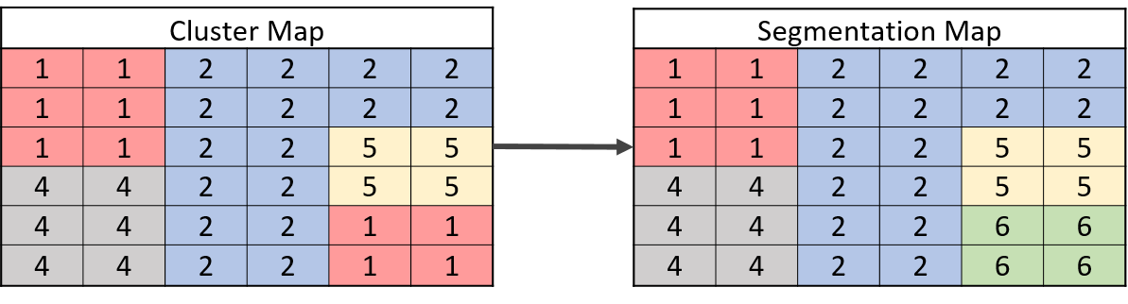

In the above image, cluster map then converted into **segmentation map** using connected component. There are two clusters having pixel label ‘1’ but both are not connected, so it will recognize as different segment.

More details can be found in the following references:

A. Mehta and O. Dikshit, “Projected clustering of hyperspectral imagery using region merging,” Remote Sensing Letters, vol. 7, no. 8, pp. 721–730, 2016.

A. Mehta and O. Dikshit, “Segmentation-based projected clustering of hyperspectral images using mutual nearest neighbour,” in IEEE Journal of Selected Topics in Applied Earth Observations and Remote Sensing, vol. 10, no. 12, 2017, pp. 5237–5244

H. Motiyani, P. K. Mali, and A. Mehta, “Hyperspectral image segmentation, feature reduction and clustering using k-means,” in 2022 International Conference on Computing, Communication, and Intelligent Systems (ICCCIS), 2022, pp. 389–393

Literary style of the paper should be improved.

The changes have been incorporated in the paper as per the suggestion.

Paper should be prepared as per template prescribed.

As per the suggestions the changes have been accommodated in the paper.

Figures are of poor resolution and clarity.

As suggested, the Figures have been enlarged and their resolution has been increased.

All parameters in equations should be elaborated in detail.

As per the suggestion the changes have been accommodated where required.

How high accuracy is achieved?

In this paper, Local Band Selection technique is utilized. In this technique, Score is calculated for each band. Score incorporates both Relevancy and Redundancy criteria. Furthermore the bands are arranged in the descending order of their Score. This leads to decrease in Redundancy while the Relevancy of the features (bands) is preserved.

Furthermore, before Local Band Selection Segmentation using k-means Clustering is deployed. This will lead to Conversion of Cluster map to Segmentation map. It will contain number of segments (group of pixels).

This results in higher accuracy of Classification.

Some minor language mistakes should be revised (Avoid using Personal Pronouns), plagiarism revision required in the section III-B.

As per the suggestion language mistakes have been corrected and plagiarism in section III-B have been checked.

**Reviewer – 2**

The paper has a clear definition of objectives and scope of the work is elaborated in the abstract and introduction sections; the introduction part needs to be revised for perfect representation of the scope of the paper.

As suggested, the introduction part of the paper has been modified.

**In Introduction:**

“The scope of this research is a new clustering technique that employs Gini Impurity. Also, a novel local band selection strategy with relevancy and redundancy concept is proposed. Here, Local Band Selection means we are using reduced bandset for each cluster. While, the rest of the paper is structured as follows. Section II describes the related work of existing studies. Section III provides a description of the methodology. The datasets and functions used are listed in Section IV. The study's results are presented in Section V. Section VI serves as the paper's conclusion.”

Related work section to be improved using tabular methods of comparing existing works.

Summary of same is shown in the Related Work.

The results can be explained with more visual representations and the quality of the figures should be increased.

As suggested, result section is modified and the quality of the figures have been increased.

List the research constraints that are faced during the process of experimentation.

As per the suggestion, the required details have been incorporated in the conclusion.

**In Conclusion:**

“The main constraint that was faced during experimentation was identification of suitable parameters for image segmentation, clustering and feature selection (band selection).”

References should be improved with more recent publications.

As suggested, new references having recent publications have been added to the paper.

**In References:**

H. Zhai, H. Zhang, L. Zhang, and P. Li, “Sparsity-based clustering for large hyperspectral remote sensing images,” IEEE Transactions on Geoscience and Remote Sensing, vol. 59, no. 12, pp. 10 410–10 424, 2021.

Q. Cao, D. Mishra, J. Wang, S. Wang, H. Hurbon, and M. Y. Berezin, “Hskl: A machine learning framework for hyperspectral image analysis,” in 2021 11th Workshop on Hyperspectral Imaging and Signal Processing: Evolution in Remote Sensing (WHISPERS), 2021, pp. 1–5.

K. Cui and R. J. Plemmons, “Unsupervised classification of aviris-ng hyperspectral images,” in 2021 11th Workshop on Hyperspectral Imaging and Signal Processing: Evolution in Remote Sensing (WHISPERS), 2021, pp. 1–5.

On an overall observation, the quality of presentation should be improved. High resolution images should be used for depiction. All figures should be adequately interpreted.As suggested, the quality of presentation has been improved, the Figures have been enlarged and their resolution has been increased.